**How To Create A Shortcut On Your Desktop**

1. Right-click on your desktop. Move your pointer over “New” and click on “Shortcut”.

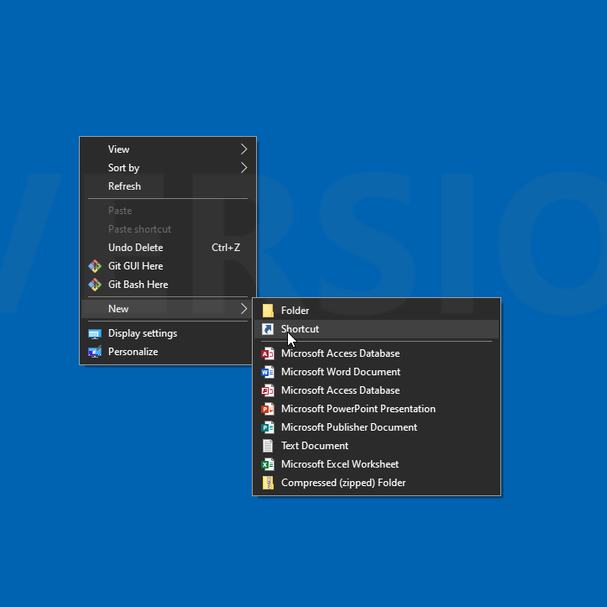

1. Open a web browser (Chrome, Firefox, etc.) and enter the URL for the website you are wanting a shortcut to on your desktop. In this example, we are using <https://charlestonwv.qscend.com/qalert>. Once you enter the URL, highlight the entire URL, right-click and select “Copy”.

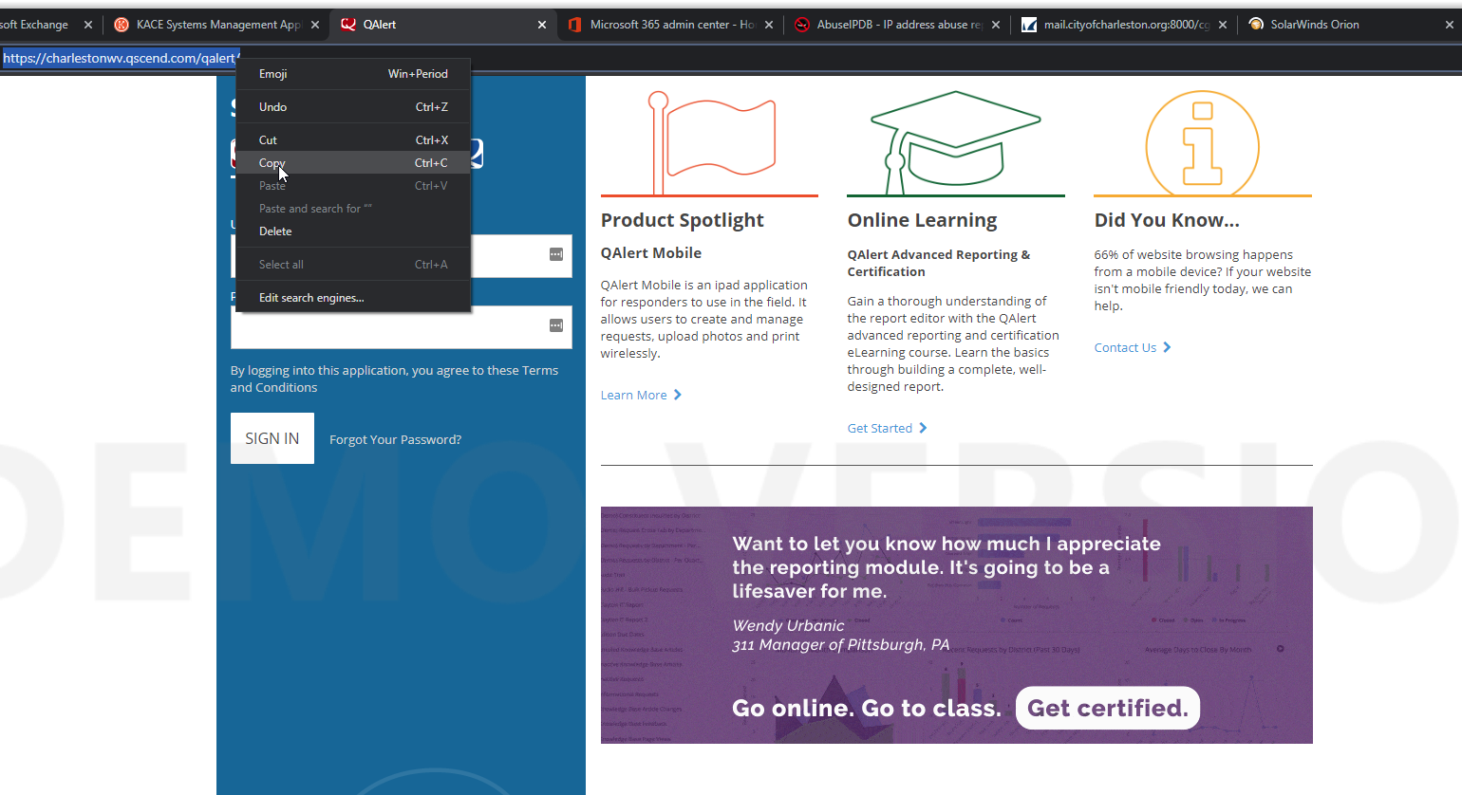

1. Right-click in the box under “Type the location of the item” and select “Paste”. Click “Next” once this box is populated.

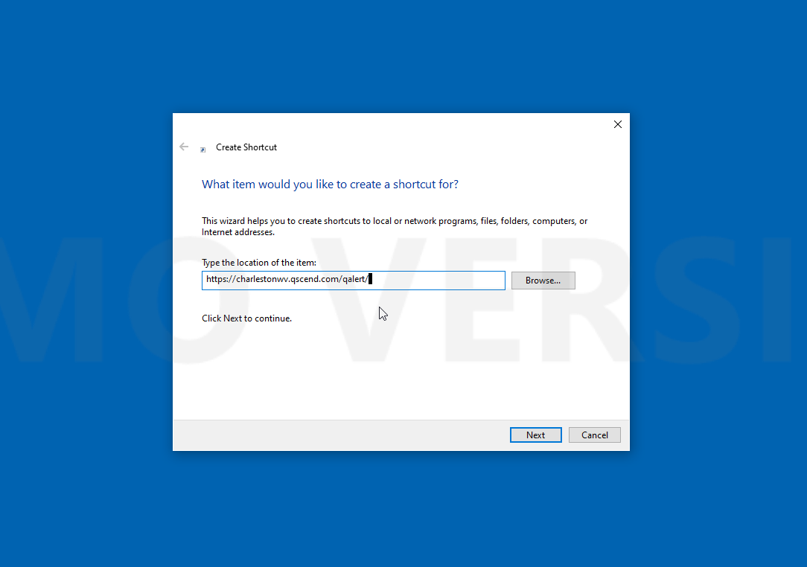

1. Enter a name for the shortcut. In this example we named the shortcut “QAlert”. Click “Finish” after you have entered a name.

