1. Open up Outlook, locate the email you want to forward and click on the desired email.

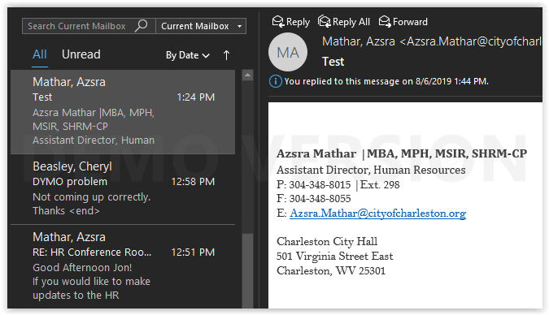

1. Locate the button highlighted in yellow below and select “Forward as Attachment”

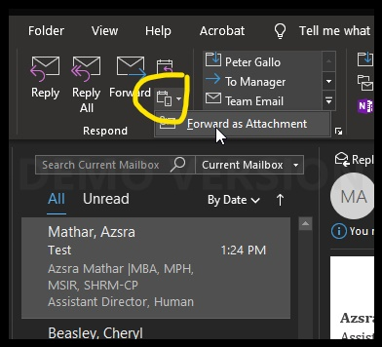

1. Enter the email address of the user(s) you wish to forward the email to. Click “Send” when you are ready to send the email

